To: Department of Energy Administrators

From: Andrew R. Thomas and Mark Henning, Energy Policy Center, Levin College of Urban Affairs, Cleveland State University, and Kirt Conrad, Chief Executive Officer, Stark Area Regional Transit Authority (through SARTA affiliates the Renewable Hydrogen Fuel Cell Collaborative (RHFCC) and the Midwest Hydrogen Center of Excellence (MHCoE).

Address: 2121 Euclid Avenue, UR 132, Cleveland State University Cleveland, Ohio 44115, 216 687 9304. Email address: a.r.thomas99@csuohio.edu and m.d.henning@csuohio.edu.

Re: Response to Earth Shot Request for Information, HFTO RFI@ee.doe.gov

Date: July 7, 2021

- Background.

Stark Area Regional Transit Authority, through its research and outreach organizations, the RHFCC and the MHCoE, and in conjunction with its research partner Cleveland State University, hereby submits this response to the Department of Energy’s Earth Shot Request for Information. The RHFCC and MHCoE are supported through Federal Transit Authority and other grants, together with SARTA funding. Both organizations collaborate with Cleveland State University and other local universities and community colleges.

- Regional Hydrogen Production, Resources, and Infrastructure.

SARTA has an existing, ongoing need for hydrogen infrastructure, including generation, storage and delivery systems. It would be able to propose, in response to an FOA, a shovel-ready project in Canton, Ohio that could demonstrate the efficacy and cost effectiveness of onsite (or locally shared) hydrogen generation for refueling infrastructure in the range of 1000 kg H2/day. This project could be a model for a series of refueling stations developed in the region. SARTA is working with Dominion Energy and others to develop a strategy for an archipelago of similar refueling stations in northern Ohio.

SARTA is currently using about 2000 kg/week (100 metric tonnes/year) to support its fleet of nearly 20 hydrogen fuel cell buses and paratransit vans. It owns and operates its own refueling/dispensing station at its bus depot in Canton, Ohio, which station is supplied by trucking liquid hydrogen generated and compressed in Sarnia, Ontario. SARTA expects to double its fleet size in the next five years, and ultimately will need hydrogen refueling infrastructure with a capacity of around 1000 kg/day, or about 200 metric tonnes/year.

The Canton, Ohio area is located in an area of low cost natural gas and low cost electricity. It is located in a growing petrochemical hub, in and around natural gas processing and developing cracker facilities. This in turn means the region has access to some of the lowest cost hydrogen generation in the nation. The challenge facing the region will be to develop this hydrogen in a manner so as to reduce the carbon dioxide and other greenhouse gas emissions. The abundant supply of natural gas resources, together with markets for carbon dioxide, provide a path forward for a low or zero carbon emission strategy with natural gas reformation. Nuclear power plants and ample biomass in the region further provide low carbon emission paths forward.

- End Users for Hydrogen in the Region, Cost, and Value Proposition.

SARTA would be the primary customer for the initial hydrogen infrastructure. However SARTA’s partners, including Dominion Energy, would seek to build similar refueling infrastructure at other area transit stations and along long haul truck corridors.

Likewise, industrial and utility demand for hydrogen in the region is expected to grow considerably. Due to the region’s large hydrogen consumption and resources to make hydrogen, it is likely that Ohio will see hubs develop in Toledo, Cleveland, Canton, into Southeast Ohio in and around the growing petrochemical industry.

Examples of regional markets include power generation, transportation, and industrial uses such as metal refining. The RHFCC/MHCoE study team projects market penetrations in the region to include the following paths.

Power Generation
Near-term plans are already underway for adding hydrogen to the fuel mix of natural gas-fired power plants in Ohio. Converting natural gas pipelines to carry a blend with up to 20% hydrogen for this purpose would likely require only modest modifications to existing infrastructure. This conversion would represent a hydrogen consumption potential of 251,200 metric tons annually by 2050 based on current fuel use for stationary power generation in the state and EIA’s projected growth in the volume of natural gas consumed for electric power generation. The figure below shows the spatial distribution of this consumption potential. The highest users are likely to include counties adjacent to Stark County.

Projected Annual Hydrogen Consumption for Stationary Power Generation
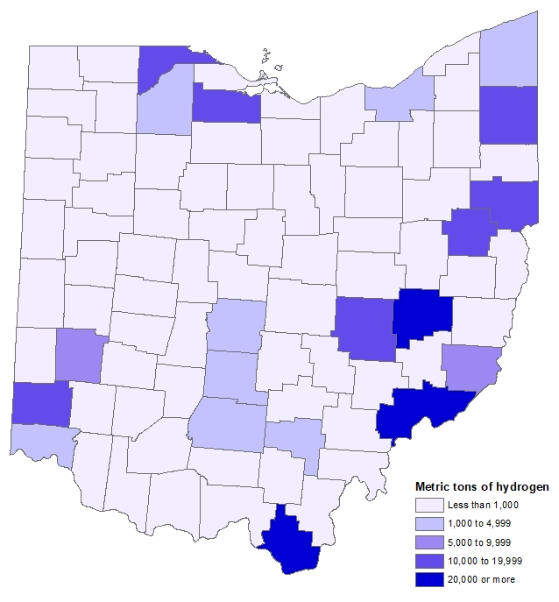

Transportation
Hydrogen-powered fuel cell electric vehicles (FCEVs) are emerging as a viable alternative to fossil fuel-powered cars, trucks, and transportation fleets. Research by Argonne National Laboratory on the total cost of ownership (TOC) for vehicles with different powertrains indicates the near-term convergence in total costs to purchase and operate FCEVs compared to those costs for fossil-fuel powered internal combustion engine vehicles (ICEVs). Based on work by both Argonne and the National Renewable Energy Laboratory, a 12% long-run market penetration for fuel cell vehicles of all class sizes in Ohio by 2050 is plausible. Should this happen, more than 430,600 metric tonnes of hydrogen will need to be supplied annually to fuel these on-road vehicles.

Projected Annual Hydrogen Consumption for FCEVs
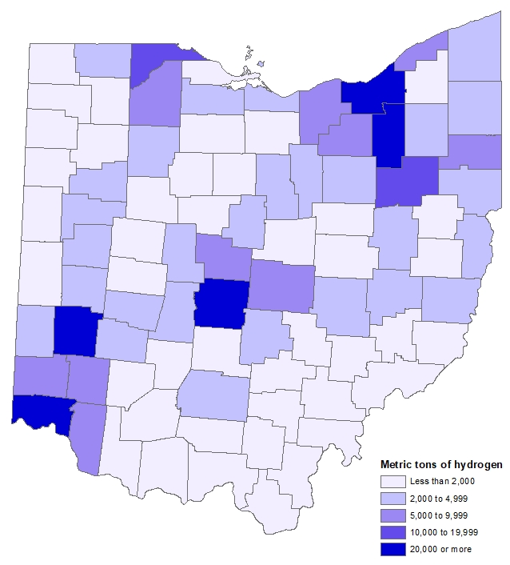

Industrial Uses
There is potential for hydrogen to be increasingly used in the iron and steel industry. Direct Reduction of Iron (DRI) using hydrogen is a more efficient process than traditional blast furnace refining. Construction has already begun at facilities in Toledo and Ashtabula that use this method of iron production. Argonne projects annual hydrogen demand of 343,000 metric tons annually in Ohio by 2050 as iron producing facilities in the state switch to DRI processes.

- Greenhouse Gas and Pollutant Emissions Reduction Potential.

SARTA’s current strategy for supplying hydrogen for its refueling infrastructure is by truck. It is cost effective, and while improving upon its diesel bus emissions, it does not sufficiently reduce greenhouse gas emissions. This is due in principal part to the emissions from trucking hydrogen by diesel from Canada to the SARTA facility. SARTA anticipates substantially reducing its carbon footprint by generation hydrogen on site or nearby. Last summer, SARTA commissioned a study led by the MHCoE to evaluate alternative strategies for supplying its facility in Canton. The results, set forth in the table below, indicated that hydrogen from SMR could be developed at a cost comparable to what SARTA is currently paying for hydrogen, and yet reduce carbon dioxide by over 40% (assuming deposit of the CO2 in nearby East Canton Oil Field for use in enhanced oil recovery).

Comparison of cost and carbon intensity for various small-scale
hydrogen production options.
Method | Cost ($/kg H₂) | Carbon Intensity (kgCO₂e/kg H₂)
SMR: delivered via LH₂ª | 5.93 | 9.81^{b}
SMR: onsite, no capture | 3.22 | 8.98
SMR: RNG, no capture | 4.49 | 2.22 – 5.32^{c}
SMR: onsite with capture (blue)
- with geological storage | 3.65 | 2.44
- with EOR/ECOF | 3.52 | 4.17
- with EOR/MCOF | 3.47 | 4.40
- with RMC | 3.27 | 2.44
Electrolysis (green) – no grid | 7.43 | 2.58
ª This hydrogen is compressed and liquified in Sarnia, Ontario, Canada, and delivered ca. 270 miles in LH₂ tanker trailers to SARTA. Importantly, this method of delivery arrives under pressure, and little or no additional onsite hydrogen compression is required for storage. This cost needs to be accounted for in a true apples to apples comparison.
^{b} The incremental carbon footprint assumes negligible boil-off losses at the Sarnia trailer refill and during transit, and emissions of 220 gCO₂e/tonne/mile due to fuel consumption.
^{c} The lower bound represents WWTP RNG at 19.34 gCO₂e/MJ and the upper bound represents landfill RNG at 46.42 gCO₂e/MJ.

Indeed, there are a number of potential carbon sinks in the region. Looking at just the I-80 corridor across the Midwest, we found the following potential sinks:

Top Potential CO2 Markets in the Midwest Region of the I-80 Corridor
Process | Current Estimated Demand (ktCO2 / yr) | Number of Sites
Ohio
Urea Manufacturing | 315.4 | 1
Food and Beverage | 73.7 | 56
Refrigeration | 38.6 | 111
Methanol | 16.0 | 2
Plastic and Polymers | 3.8 | 9
Michigan
Enhanced Oil Recovery | 323.2 | 9
Food and Beverage | 84.8 | 54
Refrigeration | 47.6 | 114
Plastic and Polymers | 10.4 | 16
Chemical Production | 0.0 | 1
Indiana
Food and Beverage | 36.4 | 24
Refrigeration | 19.8 | 57
Methanol | 10.2 | 1
Plastic and Polymers | 8.5 | 6
Pennsylvania
Food and Beverage | 90.2 | 63
Refrigeration | 42.5 | 143
Chemical Production | 16.4 | 4
Plastic and Polymers | 6.5 | 12
Miscellaneous | 0.4 | 2

Perhaps the most valuable local carbon sink is the growing regional demand for CO2 to supply ready mix concrete. RMC is the fastest growing concrete technology, and promises to solve a number of carbon capture and use challenges. The following map shows the RMC facilities in the vicinity of a proposed blue hydrogen facility in Canton:

Ready Mix Concrete Locations in Ohio, Symbolized by Potential Annual CO2 Demand for the Purpose of Incorporation into Mixed Concrete Product.

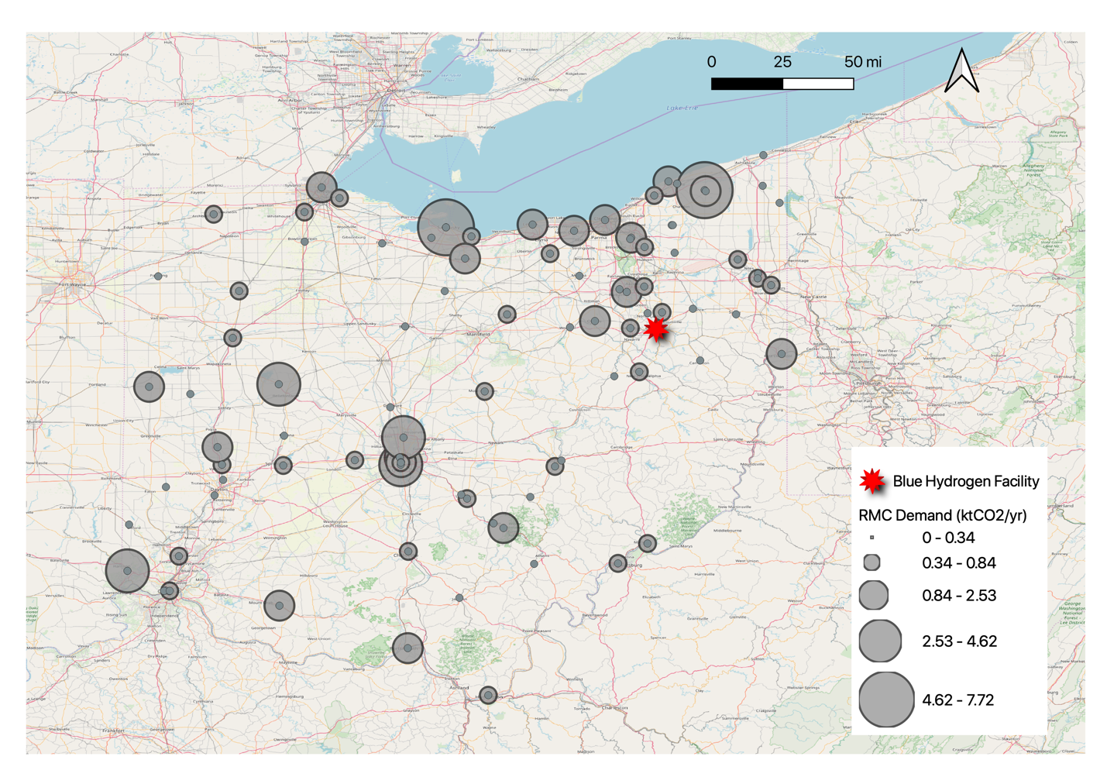

Large scale hydrogen production in the region would, of course, provide more cost reductions on the generation side, and more carbon marketing opportunities. Locating a large scale blue hydrogen facility in and around the East Canton Oil Field, for instance, would provide opportunities to both reduce the cost of hydrogen generation and take advantage of carbon markets, including 45Q federal tax credits.

Working in conjunction with Dominion Energy, SARTA has begun the process of developing an onsite hydrogen generation RFP that would address carbon reduction demands. SARTA would ideally put out an RFP that allows for multiple onsite hydrogen solutions, including electrolysis, steam reformation of natural gas and/or renewable natural gas (e.g. landfill). Depending upon the availability of other markets, SARTA would also consider hooking up a line to a local large scale hydrogen generation facility. SARTA would also consider electrolysis, especially with a microgrid solution for the campus. The most cost effective near term solution for SARTA, however, is likely to be steam reformation of natural gas. As will be discussed in the section on science and innovation needs, however, all solutions for refueling infrastructure should be developed in conjunction with a microgrid, whether its source of hydrogen is based upon SMR or electrolysis.

- Diversity, Equity, Inclusion (DEI), Jobs, and Environmental Justice.

SARTA serves a diverse, economically depressed community. SARTA requires compliance with diversity rules and equal opportunity in all of its contracts. SARTA is also located in an area that has been in the past classified as “non-attainment” for air pollution, and only recently was granted temporary attainment classification. It is at risk of returning to non-attainment. Movement to zero emission buses and trucks are a high priority for the region.

It has long been understood in Ohio that the change from internal combustion engines to electric vehicles will be disruptive to the Ohio economy, which relies heavily upon automotive and truck manufacturing. For this reason, Ohio has invested hundreds of millions of dollars, primarily through its Third Frontier Program, into fuel cell technology. CALSTART, for instance, estimated that a switch to fuel cell electric vehicles would create 60,000 jobs in Ohio. This has led to a growing fuel cell supply chain industry in Ohio.

What has been less well understood, however, is the role that hydrogen will play in job creation and retention in the industrial and power generation sectors. That is just now coming into focus, and will be the subject of additional research by the RHFCC/MHCoE in the coming year.

- Science and Innovation Needs and Challenges.

There are several challenges that can be addressed by a hydrogen project that emanates from the SARTA refueling facility in Canton. First, hydrogen generation needs to be cost effective at the mid-size, refueling station size to compete with large scale generation and trucking. Costs need to be reduced, especially for procurement/engineering/construction. Industrial gas companies already can offer hydrogen from SMR at the 1000 kg/day scale for a competitive price. But this will not matter if the procurement/engineering/construction costs drive up the price. Demonstration can help solve these problems.

Carbon capture technology also needs to be further developed, as do markets for carbon. Carbon sinks like Ready Mix Concrete companies must be willing to enter into take-or-pay contracts for five years and up. Again, demonstration can help make this feasible.

One of the most important challenges to refueling infrastructure is maintaining uptime. Local hydrogen generation, even from steam reformation of natural gas, requires that the grid remain operational. SMR requires electricity to compress both the natural gas coming into the facility, and the hydrogen coming out. Bus depots require air handlers that never go down to keep hydrogen from accumulating in the depot. And communication/information systems between buses and the transit operators must remain up. This last need has become increasingly compelling, as buses, drivers and riders rely more and more upon data. Transit needs both short term reliability (including power quality) and long term resiliency.

All refueling infrastructure, including transit, needs to operate during grid outages. All refueling infrastructure will rely increasingly upon big data. Developing strategies for resiliency, as a result, will be increasingly important. Uptime of 99.9999% can be achieved through microgrids that deploy hydrogen storage onsite, together with fuel cells and/or electrolysis. This will be an important feature of hydrogen refueling stations in the future, and SARTA would like it to be a feature of its proposed demonstration.

- Additional Information.

Expected collaborators for the proposed project at SARTA, and for a regional hydrogen hub, include: Dominion Energy, JobsOhio, Canton Chamber of Commerce, TeamNEO, Cleveland State University, Stark State Community College, and the Ohio Fuel Cell Coalition. Others, including industrial gas companies, utilities and refueling distributors will be added later.

https://www.dispatch.com/story/business/2021/02/03/long-ridge-power-plant-ohio-use-hydrogen-natural-gas/4230621001/
https://www.nrel.gov/docs/fy13osti/51995.pdf
https://www.eia.gov/outlooks/aeo/production/sub-topic-03.php.
https://publications.anl.gov/anlpubs/2021/05/167399.pdf
https://www.nrel.gov/docs/fy18osti/71083.pdf
https://www.aksteel.com/about-us/locations/cleveland-cliffs-corporate-office/hbi-plant https://www.petminusa.com/
https://greet.es.anl.gov/publication-us_future_h2
Psarras, Peter; Henning, Mark; and Thomas, Andrew R., "Economics of Carbon Capture and Storage for Small Scale Hydrogen Generation for Transit Refueling Stations" (2020). Urban Publications. 0 1 2 3 1675. https://engagedscholarship.csuohio.edu/urban_facpub/1675

